**ACKNOWLEDGEMENT**

Our heartfelt gratitude to Anjali Madam and Mamta Madam for their valuable guidance and suggestions which helped us in developing this application.

We would also like to thank our parents for their constant support and encouragement.

**TABLE OF CONTENTS**

* 1. **INTRODUCTION**
  2. **PROJECT PROFILE**
* **Title**
* **Objective**
* **Scope**
* **Technology Base**
  1. **TOOLS AND TECHNOLOGIES**

**D. DESCRIPTION**

**E. DIAGRAMS**

* **Entity Relationship Diagram**
* **Data Flow Diagram**
* **Class Diagram**

**F. MODULES**

**G. DATABASE DESCRIPTION**

* **Entity Tables**
* **Relationship Tables**

**H. ASPECTS OF JAVA COVERED**

**I. HIGHLIGHTS OF THE SYSTEM**

**G. FUTURE SCOPE**

**INTRODUCTION**

*Reader’s Delight* is a Personal Book Cataloging Application. A home for casual readers and bona-fide bookworms alike, *Reader’s Delight* helps the Users keep a track of their Reading Life in a fun and Engaging way. Books bring people together in unique ways, transcending geographic boundaries, structuring conversations, fostering ideas and new insights into each other and, *Reader’s Delight* gives you a chance to *Make your Reading, a History!*

**PROJECT PROFILE**

**Title: Reader’s Delight**

**(Personal Book Cataloguing System)**

**Objective:** Our purpose is to help Book Lovers keep an account of their ‘Reads’ and make their Book-Reading Experience last Forever through *Reader’s Delight*. Along the way, we plan to improve the process of reading and learning throughout the world.

Scope: The project, upto it’s current implementation, enables the user to archive the books he/she has read. Apart from this it facilitates the recommendation of a good number of books based on the user’s current favorites. Detailed information about the books and the authors will help users find their next read. Users can rate books-a feature that provides personalization. Report analysis generation is another key feature in the system.

Platform: Java with Oracle

TOOLS AND TECHNOLOGIES

JAVA

The system is developed using Java. The Graphical User Interface (GUI) is provided using the Swing Component of Java.

ORACLE

It is free and open source relational database, which is fast, easy to use, and having compatibility with Java.

DESCRIPTION

Reading books can be an endearing experience for serious book lovers. All they want to do is absorb themselves in the enigma of each and every page of their book. Discovering novel writings and new genres can be a treat for an avid reader. *Readers’ Delight* aspires to meet these requirements with the following features.

* Search for books

Reader’s Delight gives the user an opportunity to browse books from an extensive collection divided in different categories.

The books can be searched by their Series, written by various Authors, & published by various Publishers, from a vast spectrum of Genres.

* Get an insight

Access all kinds of details of the books viz. Cover page, its author, publisher, genre, Brief Summary, Price, Release date, Popularity Quotient.

* Categorize your Reads

The user can organize his/her books into different class like Read, Unread, or WishList  and Rate them according to his/her liking with an option to give his personal remarks.

* Bookmarking

An additional option for the user to bookmark his/her books.

* (The BookRack ):

The Homepage features a shelf – a personal space where the user’s past reads will get displayed.

* Analyze your Reading statistics:

Get Analysis of Monthly reads categorized by Read, Unread or Wishlisted.

* Get Recommendations

Reader’s Delight provides a unique feature of Book Recommendations which are based on the User’s current inclination towards different authors and genres.

* Famous Quotes

The Homepage displays prominent Quotes from different books appearing at random.

* User Profiles

Reader’s delight allows various users to manage their personal profiles each having their different choice of books.

**DIAGRAMS**

Class Diagram

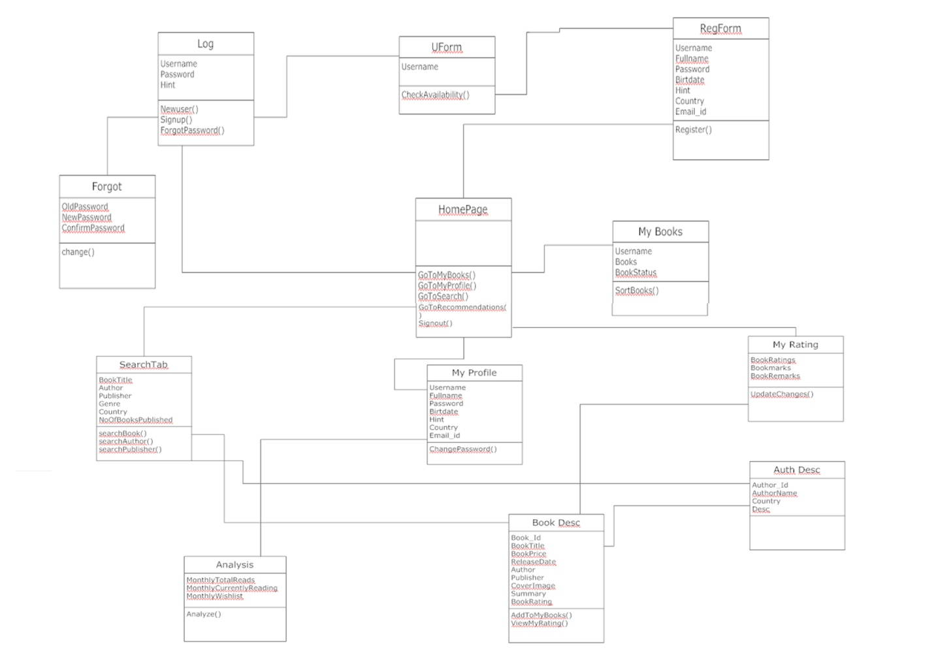

Data Flow Diagram

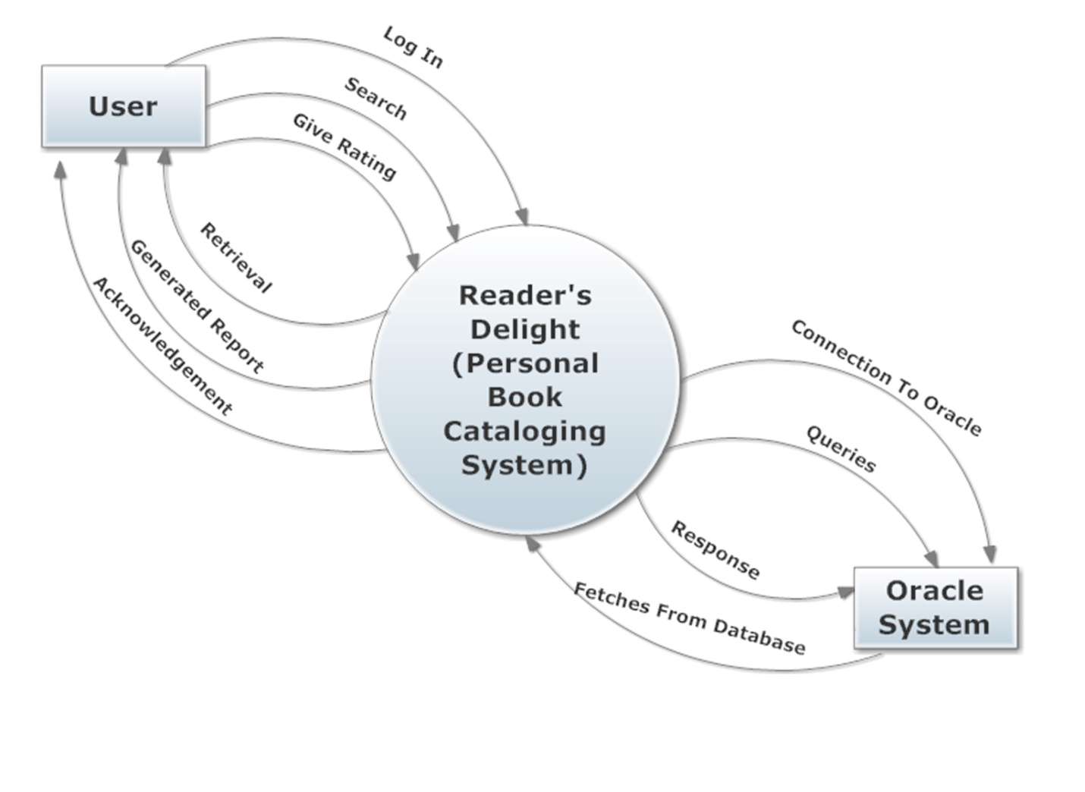

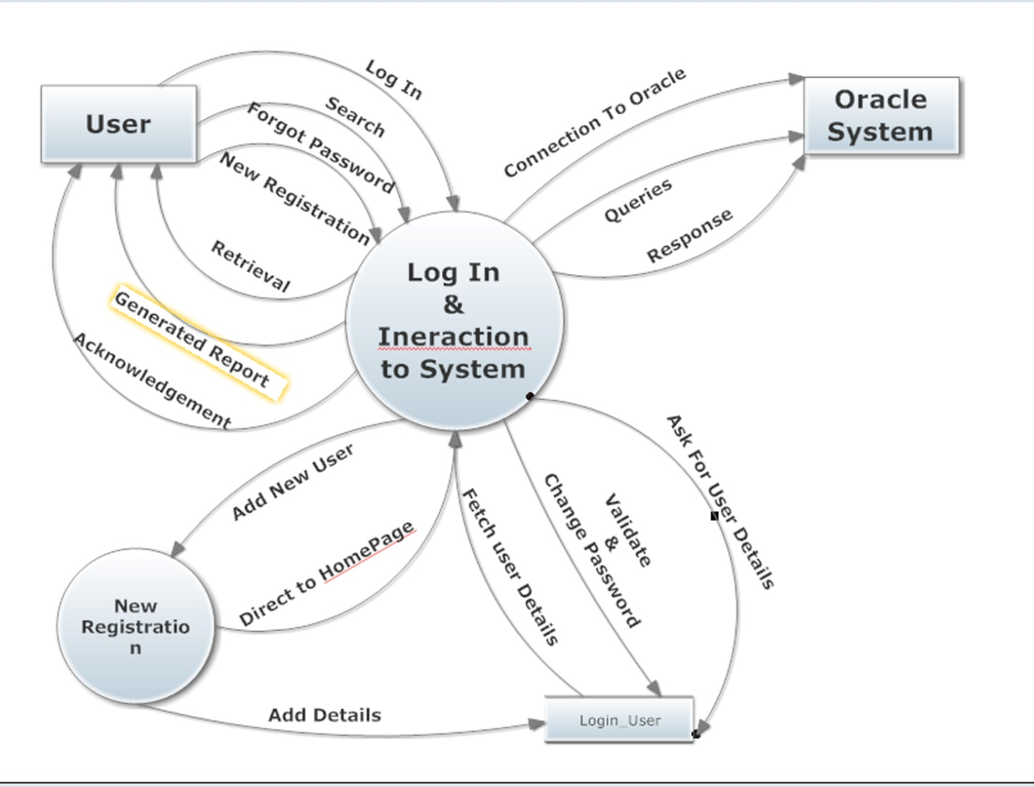

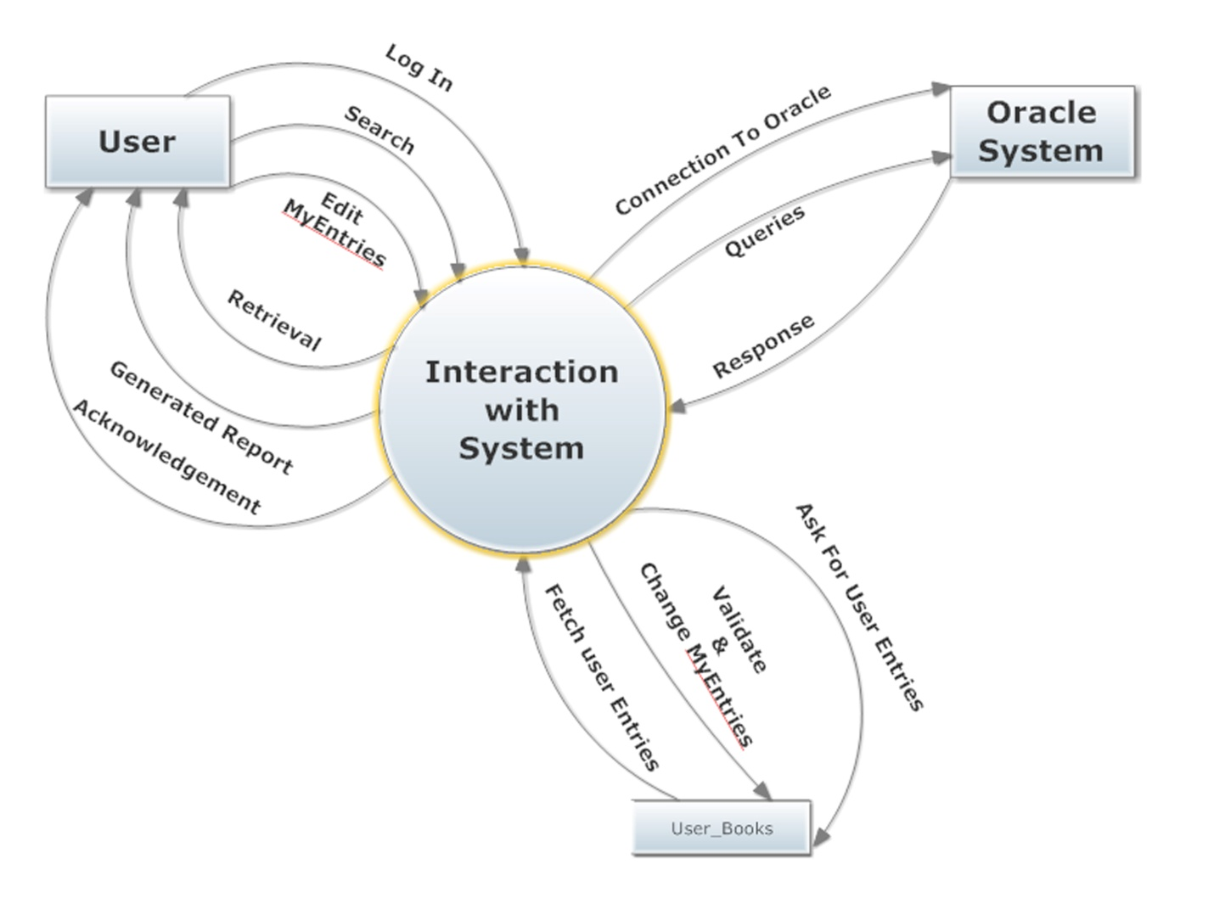

ER DIAGRAM

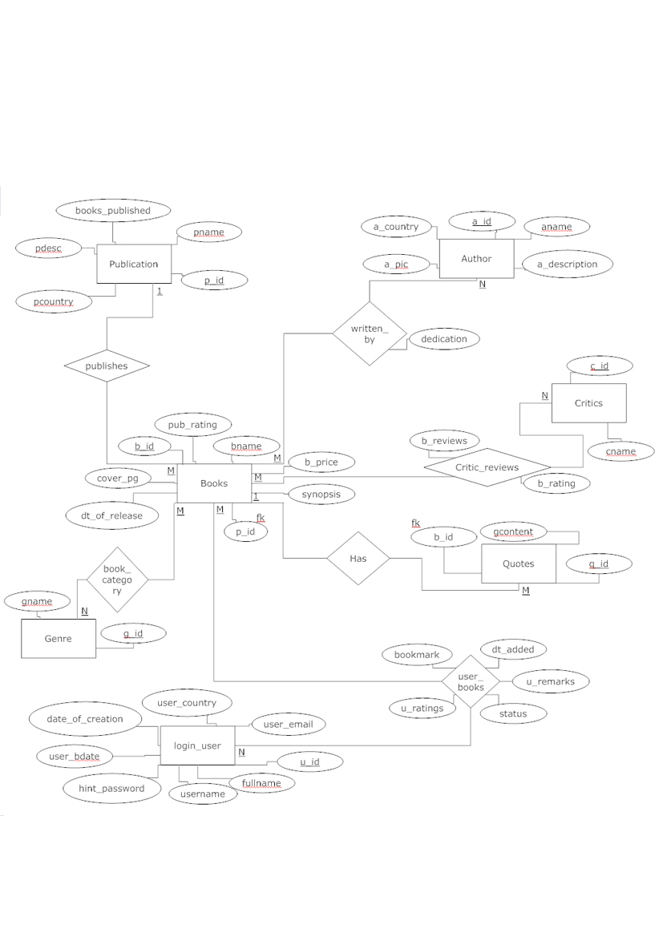

**MODULES**

Module 1: Log-in System

Through this system the user can create a new account or an existing user can log on to his/her account. The user can also find a password hint incase the password is forgotten by clicking on the Forgot Password Button. When a user creates a new account he/she will first need to create a unique username. This protocol checks the availability of the username. When a unique username is created the user can then move on to the actual registration form, fill in his personal details and complete the registration process. The user will then be directed to the homepage.

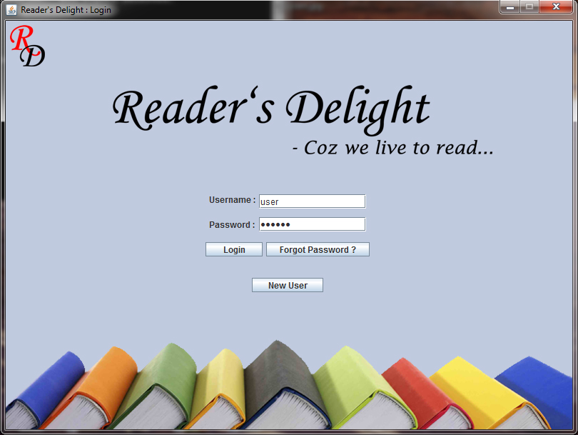

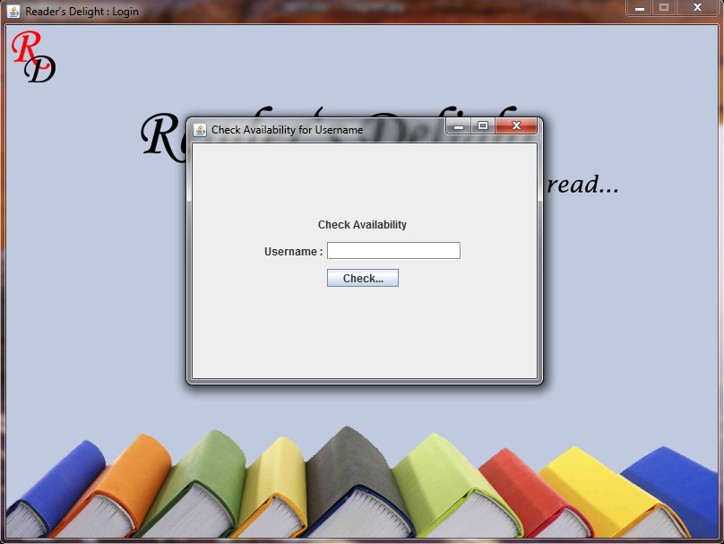

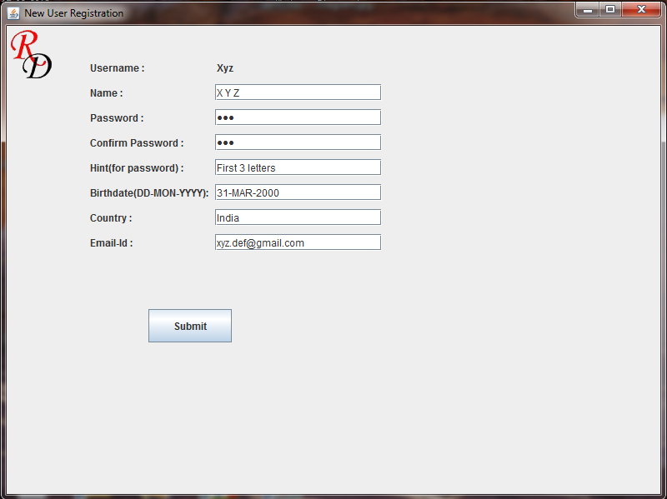

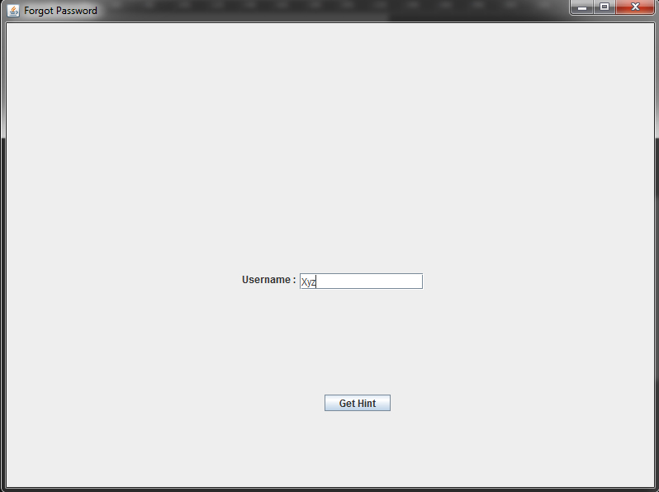

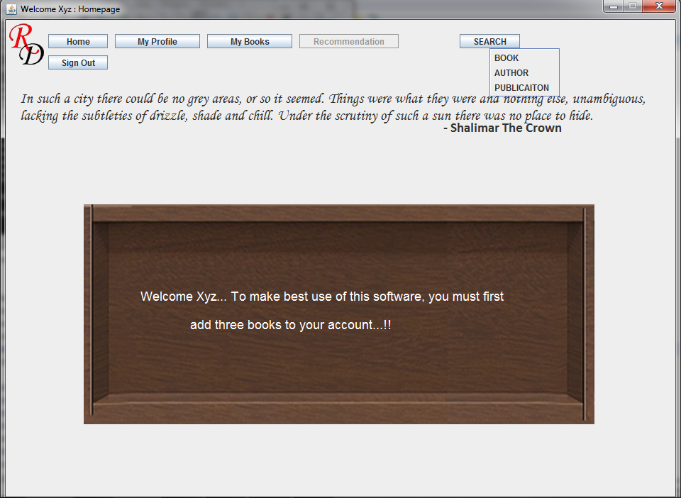

Module 2: Searching & Adding new Books

The homepage has a search option through which the user can access all the available books through the book name, author, genre, and publisher. The information about the authors and the publications can also be accessed independently. The book description shows the book name, author, cover image, price, critic ratings, date of release and a brief summary. When a book is displayed the user can add it to “My Books” and also give his remarks and ratings. The author description page simply displays the author name, his image, birth date, country and a gist of his life and work.

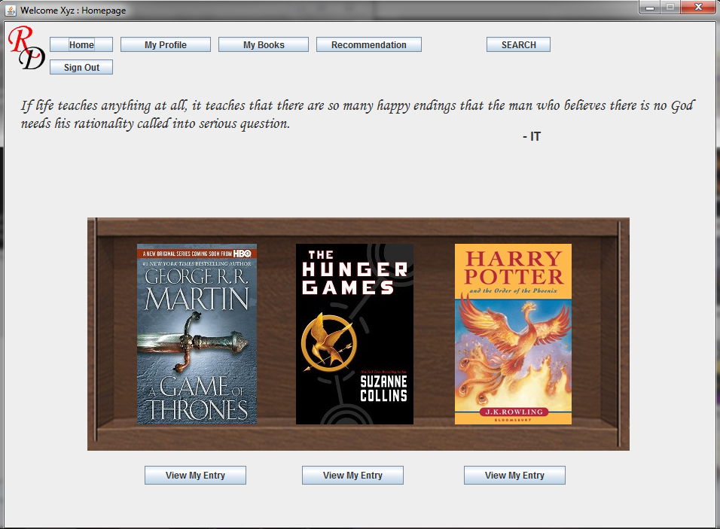

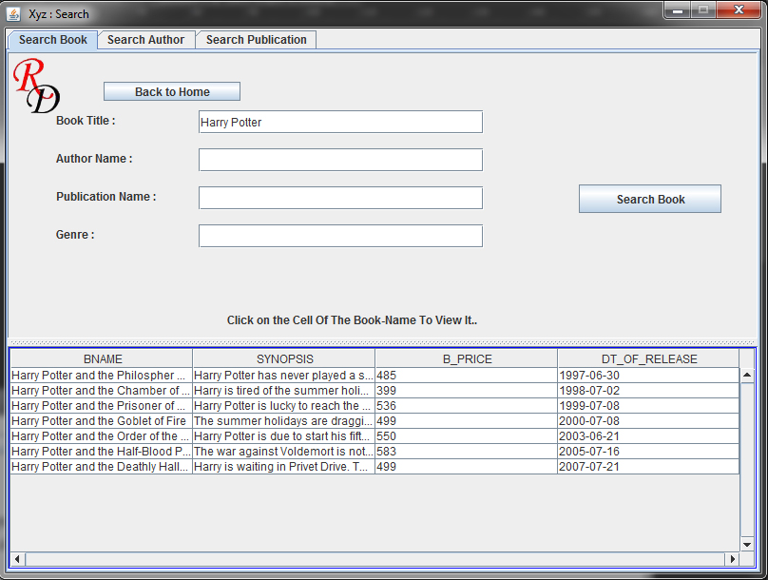

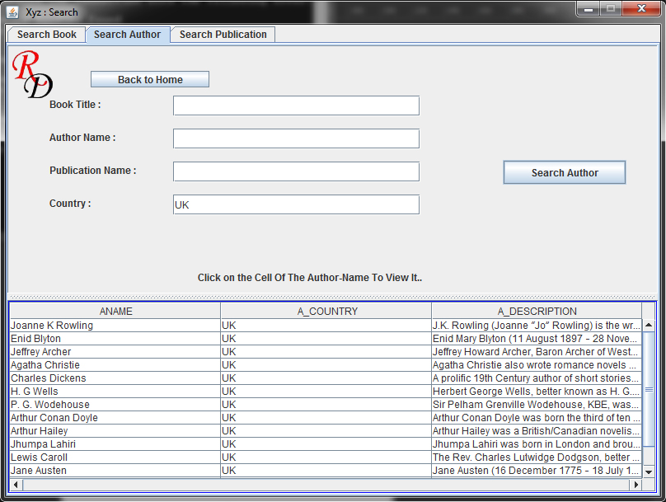

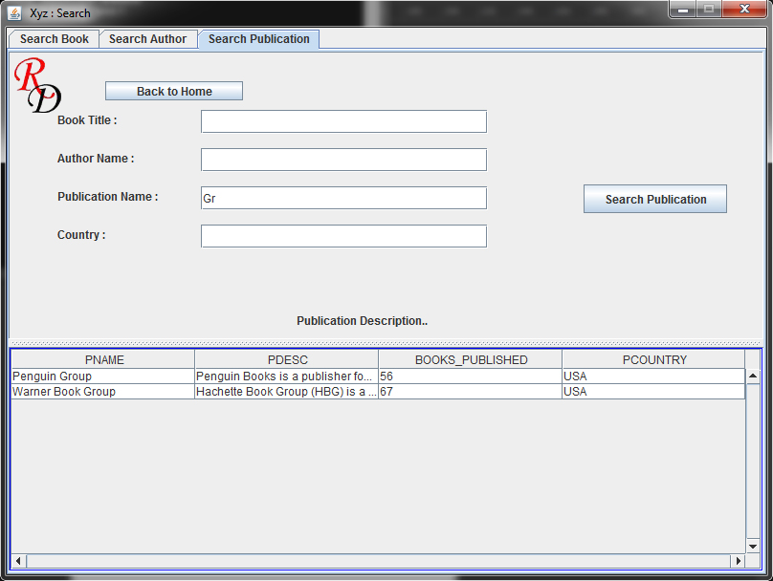

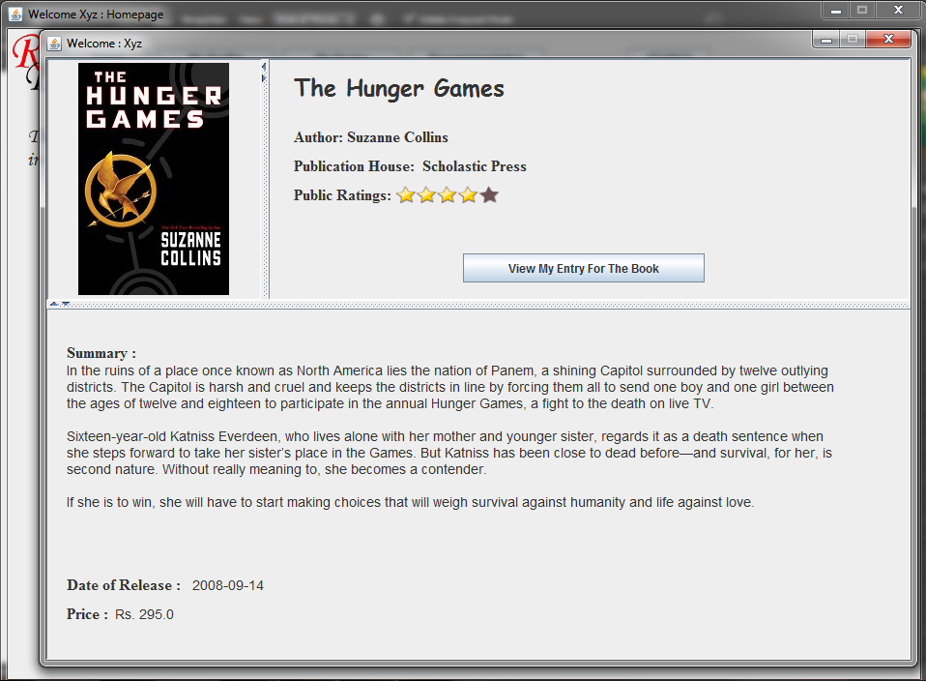

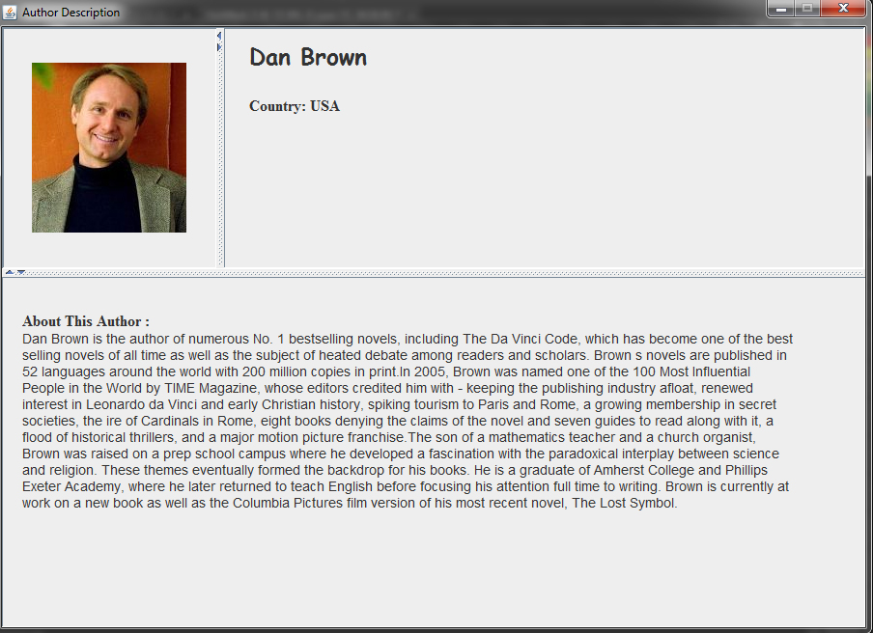

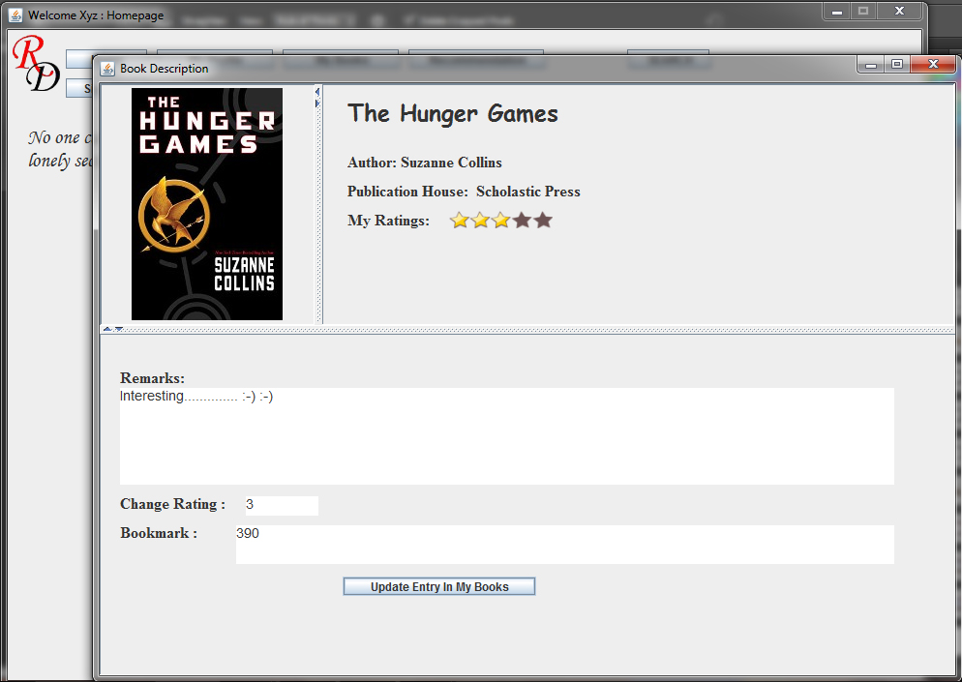

Module 3: My Books and Analysis

The books added by the user till date can be categorized as read, currently reading and wish list. The user can also generate a report by clicking on the analysis button to analyze the total number of books added till date, number of books already read this month, number of books currently being read this month and the no of books added to the wish list this month. The Recommendation features the suggestions for future reads on the basis of the user’s preferences.

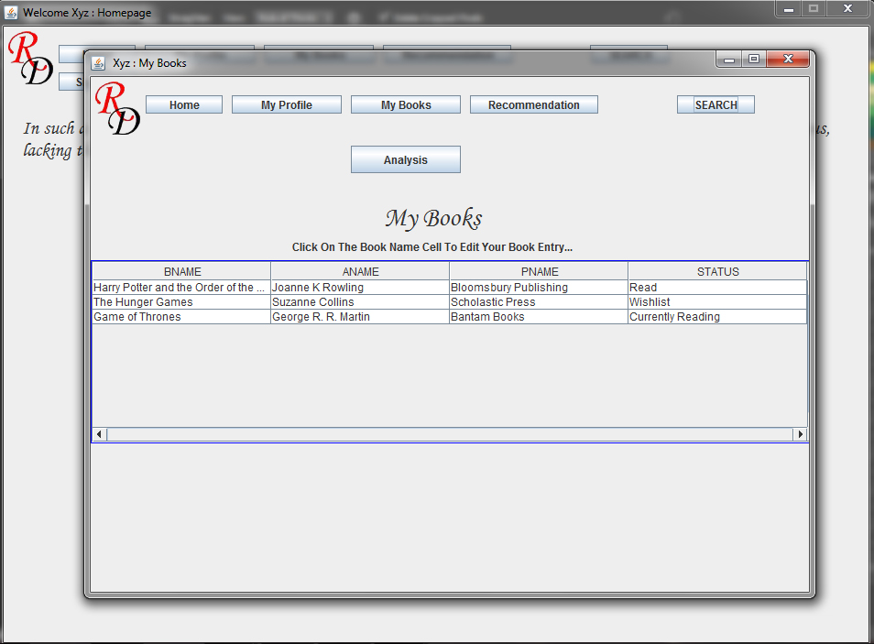

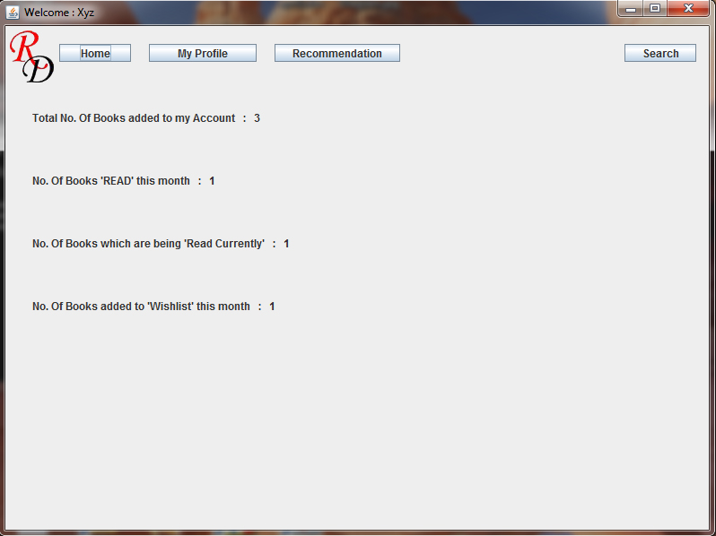

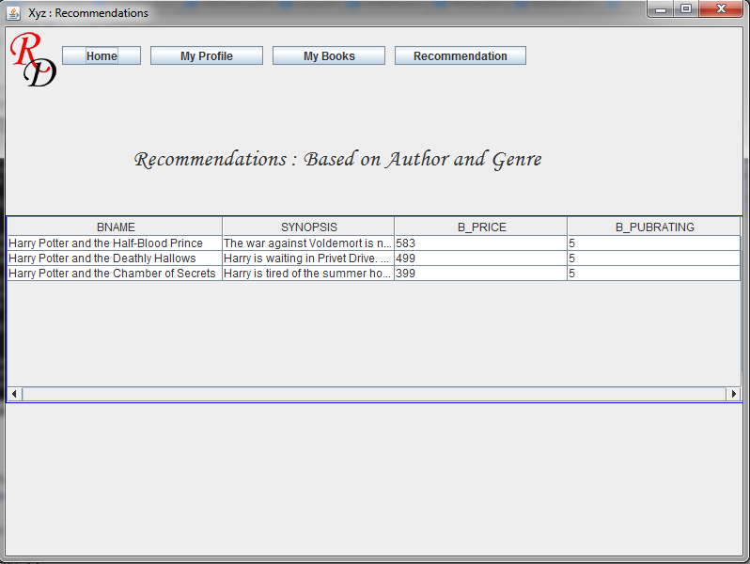

Module 4: My Profile

The user can view all his personal details he had added at the time of registration. The user can also change his current password by the available option of “Change Password”. The user is asked to enter his current password, his new password and confirm it in order to complete the process.

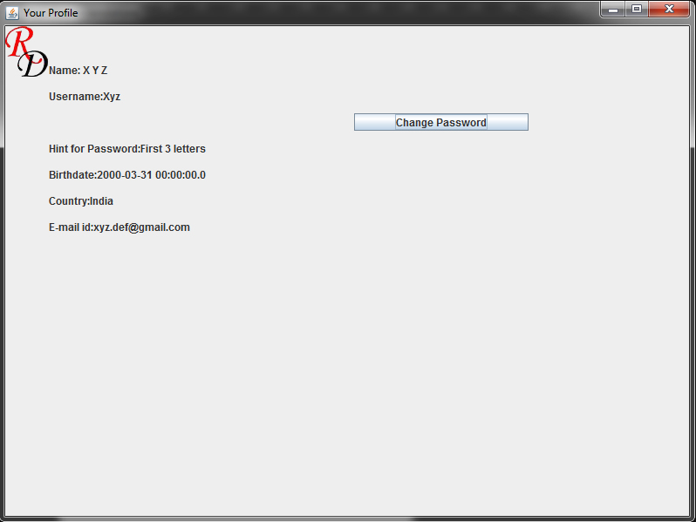

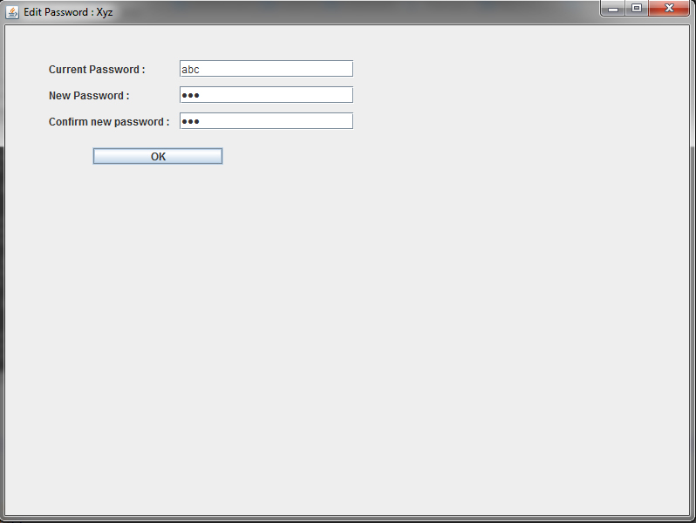

**DATABASE DESCRIPTION**

Entity Tables

1. Login_user

Contains the details about all the users of the System.

|  |  |  |  |  |  |  |  |  |  |
| --- | --- | --- | --- | --- | --- | --- | --- | --- | --- |
| **Table** | **Column** | **Data Type** | **Length** | **Precision** | **Scale** | **Primary Key** | **Nullable** | **Default** | **Comment** |
| [LOGIN_USER](javascript:ret_Column('SYSTEM.LOGIN_USER');) | [U_ID](javascript:ret_Column('U_ID');) | Number | - | 3 | 0 | 1 | - | - | - |
|  | [FULLNAME](javascript:ret_Column('FULLNAME');) | Varchar2 | 30 | - | - | - | - | - | - |
|  | [USERNAME](javascript:ret_Column('USERNAME');) | Varchar2 | 20 | - | - | - | - | - | - |
|  | [PASSWORD](javascript:ret_Column('PASSWORD');) | Varchar2 | 20 | - | - | - | - | - | - |
|  | [HINT_PASSWORD](javascript:ret_Column('HINT_PASSWORD');) | Varchar2 | 40 | - | - | - | - | - | - |
|  | [USER_BDATE](javascript:ret_Column('USER_BDATE');) | Date | 7 | - | - | - | nullable | - | - |
|  | [DATE_OF_CREATION](javascript:ret_Column('DATE_OF_CREATION');) | Date | 7 | - | - | - | nullable | - | - |
|  | [USER_COUNTRY](javascript:ret_Column('USER_COUNTRY');) | Varchar2 | 20 | - | - | - | nullable | - | - |
|  | [USER_EMAIL](javascript:ret_Column('USER_EMAIL');) | Varchar2 | 1000 | - | - | - | nullable | - | - |

1. Books

Contains the details of all the Books of the System.

|  |  |  |  |  |  |  |  |  |  |
| --- | --- | --- | --- | --- | --- | --- | --- | --- | --- |
| **Table** | **Column** | **Data Type** | **Length** | **Precision** | **Scale** | **Primary Key** | **Nullable** | **Default** | **Comment** |
| [BOOKS](javascript:ret_Column('SYSTEM.BOOKS');) | [B_ID](javascript:ret_Column('B_ID');) | Number | - | 5 | 0 | 1 | - | - | - |
|  | [BNAME](javascript:ret_Column('BNAME');) | Varchar2 | 100 | - | - | - | - | - | - |
|  | [SYNOPSIS](javascript:ret_Column('SYNOPSIS');) | Varchar2 | 2000 | - | - | - | nullable | - | - |
|  | [B_PRICE](javascript:ret_Column('B_PRICE');) | Number | - | 7 | 2 | - | - | - | - |
|  | [DT_OF_RELEASE](javascript:ret_Column('DT_OF_RELEASE');) | Date | 7 | - | - | - | nullable | - | - |
|  | [COVER_PG](javascript:ret_Column('COVER_PG');) | Varchar2 | 100 | - | - | - | - | - | - |
|  | [B_PUBRATING](javascript:ret_Column('B_PUBRATING');) | Number | - | 1 | 0 | - | - | - | - |
|  | [P_ID](javascript:ret_Column('P_ID');) | Number | - | 5 | 0 | - | nullable | - | - |

|  |  |  |  |
| --- | --- | --- | --- |
|  |  |  |  |

1. Publication

Contains the details of all the Publication Houses.

|  |  |  |  |  |  |  |  |  |  |
| --- | --- | --- | --- | --- | --- | --- | --- | --- | --- |
| **Table** | **Column** | **Data Type** | **Length** | **Precision** | **Scale** | **Primary Key** | **Nullable** | **Default** | **Comment** |
| [PUBLICATION](javascript:ret_Column('SYSTEM.PUBLICATION');) | [P_ID](javascript:ret_Column('P_ID');) | Number | - | 5 | 0 | 1 | - | - | - |
|  | [PNAME](javascript:ret_Column('PNAME');) | Varchar2 | 75 | - | - | - | - | - | - |
|  | [PDESC](javascript:ret_Column('PDESC');) | Varchar2 | 3000 | - | - | - | nullable | - | - |
|  | [PCOUNTRY](javascript:ret_Column('PCOUNTRY');) | Varchar2 | 50 | - | - | - | - | - | - |
|  | [BOOKS_PUBLISHED](javascript:ret_Column('BOOKS_PUBLISHED');) | Number | - | 5 | 0 | - | nullable | - | - |

1. Author

Contains the details of all the Authors.

|  |  |  |  |  |  |  |  |  |  |
| --- | --- | --- | --- | --- | --- | --- | --- | --- | --- |
| **Table** | **Column** | **Data Type** | **Length** | **Precision** | **Scale** | **Primary Key** | **Nullable** | **Default** | **Comment** |
| [AUTHOR](javascript:ret_Column('SYSTEM.AUTHOR');) | [A_ID](javascript:ret_Column('A_ID');) | Number | - | 5 | 0 | 1 | - | - | - |
|  | [ANAME](javascript:ret_Column('ANAME');) | Varchar2 | 50 | - | - | - | - | - | - |
|  | [A_COUNTRY](javascript:ret_Column('A_COUNTRY');) | Varchar2 | 30 | - | - | - | - | - | - |
|  | [A_DESCRIPTION](javascript:ret_Column('A_DESCRIPTION');) | Varchar2 | 2000 | - | - | - | nullable | - | - |
|  | [A_PIC](javascript:ret_Column('A_PIC');) | Varchar2 | 100 | - | - | - | - | - | - |

1. Genre

Contains all the details of Genre.

|  |  |  |  |  |  |  |  |  |  |
| --- | --- | --- | --- | --- | --- | --- | --- | --- | --- |
| **Table** | **Column** | **Data Type** | **Length** | **Precision** | **Scale** | **Primary Key** | **Nullable** | **Default** | **Comment** |
| [GENRE](javascript:ret_Column('SYSTEM.GENRE');) | [G_ID](javascript:ret_Column('G_ID');) | Number | - | 3 | 0 | 1 | - | - | - |
|  | [GNAME](javascript:ret_Column('GNAME');) | Varchar2 | 30 | - | - | - | - | - | - |

1. Critic

Contains specifics of all th Critics.

|  |  |  |  |  |  |  |  |  |  |
| --- | --- | --- | --- | --- | --- | --- | --- | --- | --- |
| **Table** | **Column** | **Data Type** | **Length** | **Precision** | **Scale** | **Primary Key** | **Nullable** | **Default** | **Comment** |
| [CRITIC](javascript:ret_Column('SYSTEM.CRITIC');) | [C_ID](javascript:ret_Column('C_ID');) | Number | - | 5 | 0 | 1 | - | - | - |
|  | [CNAME](javascript:ret_Column('CNAME');) | Varchar2 | 30 | - | - | - | - | - | - |
|  | [C_DESCRIPTION](javascript:ret_Column('C_DESCRIPTION');) | Varchar2 | 500 | - | - | - | nullable | - | - |

1. Quotes

Contains the Quotes’ Details.

|  |  |  |  |  |  |  |  |  |  |
| --- | --- | --- | --- | --- | --- | --- | --- | --- | --- |
| **Table** | **Column** | **Data Type** | **Length** | **Precision** | **Scale** | **Primary Key** | **Nullable** | **Default** | **Comment** |
| [QUOTES](javascript:ret_Column('SYSTEM.QUOTES');) | [Q_ID](javascript:ret_Column('Q_ID');) | Number | - | 3 | 0 | 1 | - | - | - |
|  | [QCONTENT](javascript:ret_Column('QCONTENT');) | Varchar2 | 500 | - | - | - | - | - | - |
|  | [B_ID](javascript:ret_Column('B_ID');) | Number | - | 5 | 0 | - | nullable | - | - |

|  |  |  |  |
| --- | --- | --- | --- |
|  |  |  |  |

Relation Tables

1. Written_By

Contains the relation between Books & Authors.

|  |  |  |  |  |  |  |  |  |  |
| --- | --- | --- | --- | --- | --- | --- | --- | --- | --- |
| **Table** | **Column** | **Data Type** | **Length** | **Precision** | **Scale** | **Primary Key** | **Nullable** | **Default** | **Comment** |
| [WRITTEN_BY](javascript:ret_Column('SYSTEM.WRITTEN_BY');) | [B_ID](javascript:ret_Column('B_ID');) | Number | - | 5 | 0 | 1 | - | - | - |
|  | [A_ID](javascript:ret_Column('A_ID');) | Number | - | 5 | 0 | 2 | - | - | - |
|  | [DEDICATION](javascript:ret_Column('DEDICATION');) | Varchar2 | 100 | - | - | - | nullable | - | - |

1. User_books

Contains the relation between Login_User & Books.

|  |  |  |  |  |  |  |  |  |  |
| --- | --- | --- | --- | --- | --- | --- | --- | --- | --- |
| **Table** | **Column** | **Data Type** | **Length** | **Precision** | **Scale** | **Primary Key** | **Nullable** | **Default** | **Comment** |
| [USER_BOOKS](javascript:ret_Column('SYSTEM.USER_BOOKS');) | [U_ID](javascript:ret_Column('U_ID');) | Number | - | 3 | 0 | 1 | - | - | - |
|  | [B_ID](javascript:ret_Column('B_ID');) | Number | - | 5 | 0 | 2 | - | - | - |
|  | [U_RATING](javascript:ret_Column('U_RATING');) | Number | - | 2 | 0 | - | nullable | - | - |
|  | [U_REMARKS](javascript:ret_Column('U_REMARKS');) | Varchar2 | 1000 | - | - | - | nullable | - | - |
|  | [DT_ADDED](javascript:ret_Column('DT_ADDED');) | Date | 7 | - | - | - | nullable | - | - |
|  | [STATUS](javascript:ret_Column('STATUS');) | Varchar2 | 30 | - | - | - | nullable | - | - |
|  | [BOOKMARK](javascript:ret_Column('BOOKMARK');) | Varchar2 | 50 | - | - | - | nullable | - | - |

1. Critic Reviews

Contains the relationship between the Books & Critics

|  |  |  |  |  |  |  |  |  |  |
| --- | --- | --- | --- | --- | --- | --- | --- | --- | --- |
| **Table** | **Column** | **Data Type** | **Length** | **Precision** | **Scale** | **Primary Key** | **Nullable** | **Default** | **Comment** |
| [CRITIC_REVIEWS](javascript:ret_Column('SYSTEM.CRITIC_REVIEWS');) | [B_ID](javascript:ret_Column('B_ID');) | Number | - | 5 | 0 | 1 | - | - | - |
|  | [C_ID](javascript:ret_Column('C_ID');) | Number | - | 5 | 0 | 2 | - | - | - |
|  | [B_RATING](javascript:ret_Column('B_RATING');) | Number | - | 2 | 0 | - | - | - | - |
|  | [B_REVIEW](javascript:ret_Column('B_REVIEW');) | Varchar2 | 1000 | - | - | - | nullable | - | - |

1. Book_Category

Contains the relationship between the Books & Genre.

|  |  |  |  |  |  |  |  |  |  |
| --- | --- | --- | --- | --- | --- | --- | --- | --- | --- |
| **Table** | **Column** | **Data Type** | **Length** | **Precision** | **Scale** | **Primary Key** | **Nullable** | **Default** | **Comment** |
| [BOOK_CATEGORY](javascript:ret_Column('SYSTEM.BOOK_CATEGORY');) | [B_ID](javascript:ret_Column('B_ID');) | Number | - | 5 | 0 | 1 | - | - | - |
|  | [G_ID](javascript:ret_Column('G_ID');) | Number | - | 3 | 0 | 2 | - | - | - |

|  |  |  |  |
| --- | --- | --- | --- |
|  |  |  |  |
|  |  |  |  |

**ASPECTS OF JAVA COVERED**

According to the level of detailing done up to this point, we have be covering the below mentioned aspects Of Java.

1. Graphical & User Interface
2. Inheritance
3. Interface
4. Packages
5. Event Handling
6. Exception Handling
7. Swing and AWT
8. Imports

**HIGHLIGHTS OF THE SYSTEM**

**1.**

**2. Quotes:**

The well known quotes from various books will be displayed randomly on the home page and will be updates at regular intervals. The name of the books will also be displayed.

**3. Clickable Records**

The records that will be retrieved as a result of the search will all be clickable and will direct the user to the respective book description page.

**THE FUTURE SCOPE**

By assimilating advanced Java features like Servlet and Networking the scope of this system can be substantially expanded. We can develop the social aspect of the application wherein the users can be allowed increased interaction with the other users. Facilities like following other readers, sharing views and reviews and much more. Thus transforming the cataloguing system, from a Personal to a Social one.

For the time being the database contains a limited amount of books. This can be expanded and maintained on a daily basis as the system grows.